NIP Project — Submission Template
Pega Platform project · This document is your complete submission
Read this before you start:
1. Fill in Section 1 completely. The Pega application name must follow the format NIP-[Project]-[YourName].
2. Create a new Operator in Pega with your full name and log in as that operator before taking any screenshot.
3. When you create your test case, enter YOUR FULL NAME in the Issue Description (Vehicle) or Movie Name (Movie) field.
4. Complete only the section for your chosen project. Delete the other project section.
5. Paste one screenshot per user story (10 total). Follow the screenshot rules in your selected project section.
6. Answer every question in Sections 3 and 4 in your own words.
7. Save the file using this format: ProjectName_FirstName_LastName.docx. Use VehicleService or MovieTicket as the ProjectName. Examples: VehicleService_Ravi_Kumar.docx or MovieTicket_Ravi_Kumar.docx.

Section 1 — Your Details
Full Name | Daggupati Goutham Raj
Email ID (registered on NIP) | daggupatigoutham05@gmail.com
Phone Number | 6301932723
College Name | G.Pullaiah College of Engineering and Technology
Course (e.g. IT, CS) | Computer Science and Artificial Intelligence
State | Andhra Pradesh
Project Chosen (Vehicle Service OR Movie Ticket Booking) | Movie Ticket Booking
Pega Application Name (e.g. NIP-VehicleService-YourName) | NIP-MovieTicket-GouthamRaj
Case Type Name (exact) | Movie Ticket Request
Pega Instance URL | https://lrrm5ctw.pegaacademy.net/prweb/app/MovieTicketRequest/
Operator Name (created in Pega with your full name) | GouthamRaj Daggupati

Section 2B — Movie Ticket Booking Management Application
Complete this section only if you selected this project. Delete the other project section before submitting.

Screenshot rules — IMPORTANT before you start:
1. Name your Pega application as: NIP-VehicleService-YourName OR NIP-MovieTicket-YourName
2. Create a new Operator in Pega with your full name (Security → Operators) and log in as that operator.
3. When you create your test case, enter YOUR FULL NAME in the Issue Description (Vehicle) or Movie Name (Movie) field.
4. The logged-in operator name must be visible in every screenshot wherever the Pega interface displays it.
5. The student's full name must be visible in all running-case screenshots.
6. Configuration screenshots must clearly show the relevant application or rule name.
Screenshots that do not show these will not be accepted.

US-001 — Submit Movie Ticket Request
What is expected:
Case created, customer submits Movie Name, Show Date, Show Time, Number of Tickets. Validation applied.
Screenshot — paste your screenshot below this line:
[ Paste screenshot here - follow the screenshot rules above ]
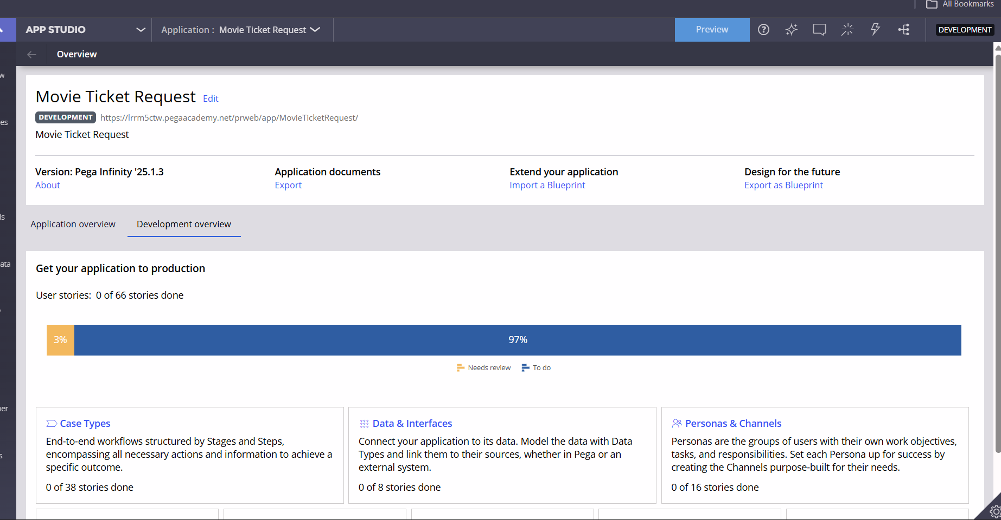

What I built for this (1–2 lines in your own words):
I built this Application

US-002 — Check Show Availability
What is expected:
Availability stage. Seat Availability Status and Available Seats Count captured. Booking proceeds only if available.
Screenshot — paste your screenshot below this line:
[ Paste screenshot here - fo 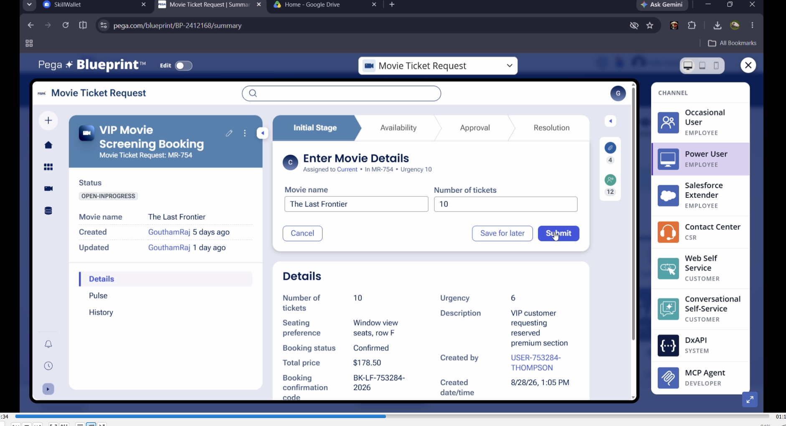llow the screenshot rules above ]

What I built for this (1–2 lines in your own words):
Here is the booking

US-003 — Calculate Booking Cost
What is expected:
Total Cost calculated automatically from Ticket Price and Number of Tickets using a business rule.
Screenshot — paste your screenshot below this line:
[ Paste screenshot here - follow the screenshot rules above ]
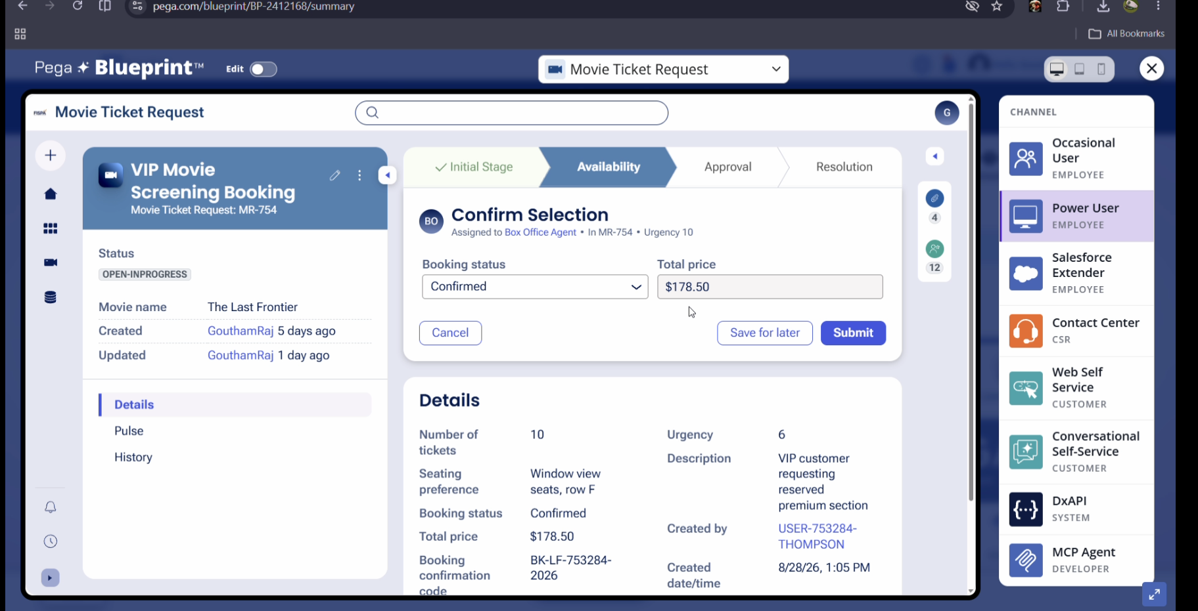

What I built for this (1–2 lines in your own words):
Its around 178$

US-004 — Confirm Booking Request
What is expected:
Approval stage assigned to Customer. Booking Status captured. Flow branches on confirm/cancel.
Screenshot — paste your screenshot below this line:
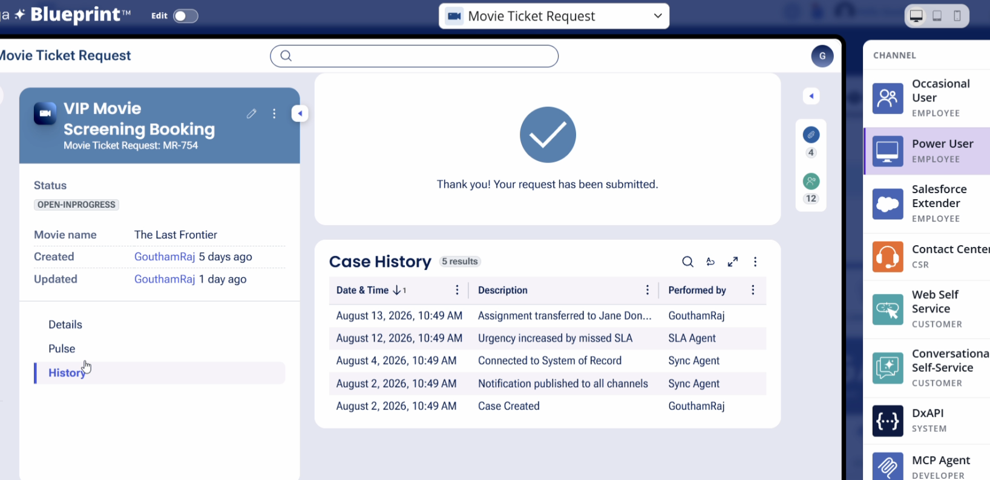

What I built for this (1–2 lines in your own words):
Booked

US-005 — Maintain Movie and Show Data
What is expected:
Reusable Movie and Show data objects created with Movie Name, Genre, Show Date, Show Time, Seat Capacity — linked to case.
Screenshot — paste your screenshot below this line:
[ Paste screenshot here - follow the screenshot rules above ]
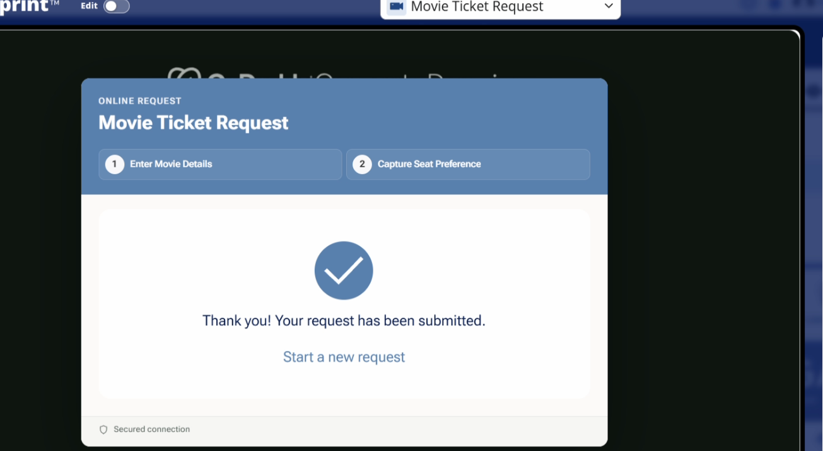

What I built for this (1–2 lines in your own words):
Success

US-006 — Review Booking Details
What is expected:
Confirmation screen shows Movie Name, Show Timing, Number of Tickets and Total Cost clearly.
Screenshot — paste your screenshot below this line:
[ Paste screenshot here - follow the screenshot rules above ]
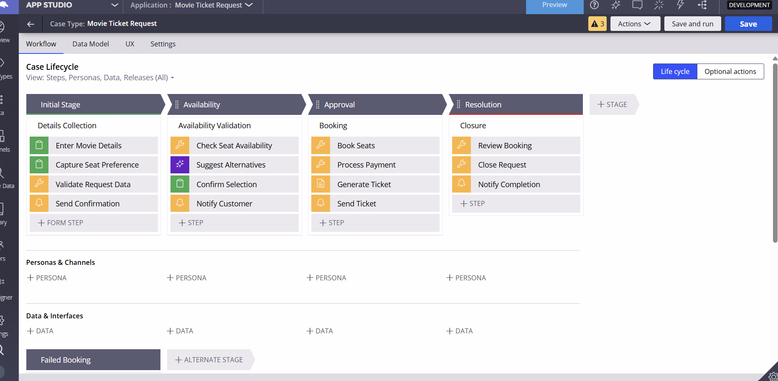

What I built for this (1–2 lines in your own words):
[ Type here ]

US-007 — Process Ticket Booking
What is expected:
Booking Execution stage. Seat Numbers, Ticket ID and Booking Confirmation Status maintained.
Screenshot — paste your screenshot below this line:
[ Paste screenshot here - follow 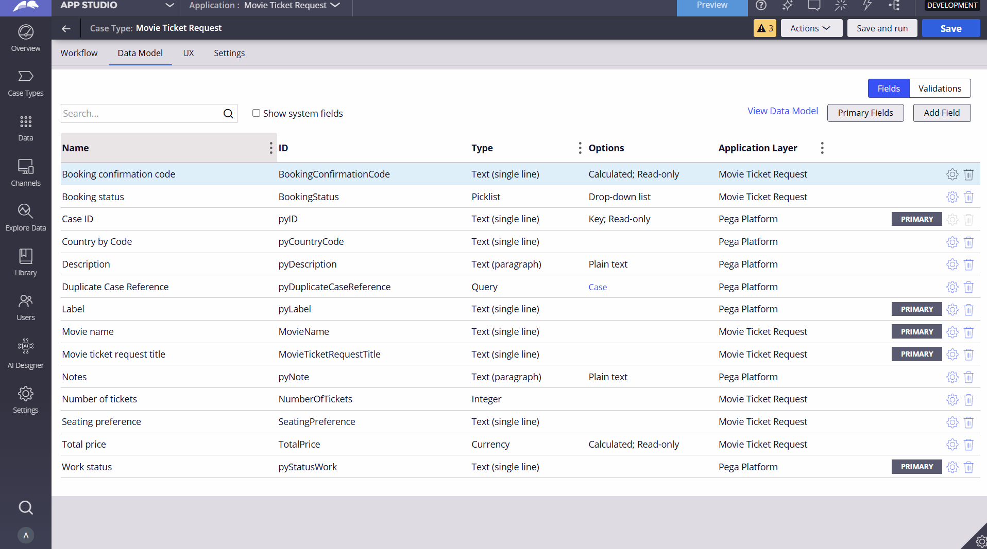 the screenshot rules above ]

What I built for this (1–2 lines in your own words):
[ Type here ]

US-008 — Notify Booking Confirmation
What is expected:
Correspondence rule triggered on case resolution. Email includes movie, show, seat and cost details.
Screenshot — paste your screenshot below this line:


What I built for this (1–2 lines in your own words):
[ Type here ]

US-009 — Define Booking SLA
What is expected:
SLA configured on the case type. Goal: 1 day. Deadline: 2 days. Priority increases on breach.
Screenshot — paste your screenshot below this line:
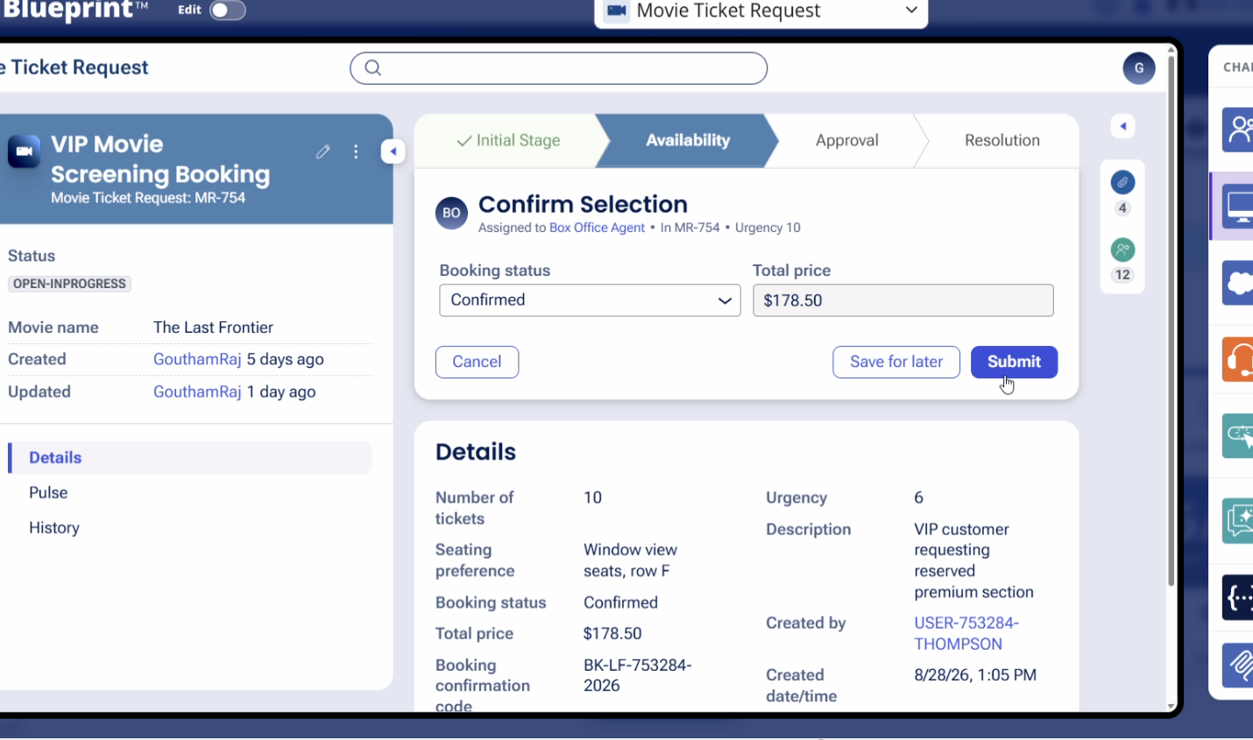

What I built for this (1–2 lines in your own words):
[ Type here ]

US-010 — Route by Show Type
What is expected:
Routing rule or Decision Table routes to PremiumShowQueue or StandardShowQueue based on Show Type property.
Screenshot — paste your screenshot below this line:


What I built for this (1–2 lines in your own words):
[ Type here ]

Section 3 — About Your Application
These answers are checked against your screenshots. Write exactly what is in your application.

Q1. List your stages in the order they appear in your case lifecycle.
Stage names in order, separated by commas.
Good and Shop

Q2. Name the data object(s) you created and the properties inside them.
Data object name and its properties.
Case and Barrel

Q3. What is the exact name and type of the rule you used to calculate Total Cost?
Provide:
• Rule Name
• Rule Type
• Properties used in the calculation
• Formula used
Standard

Section 4 — Your Understanding
Short, honest and specific answers score well.

Q4. What did Blueprint generate for you, and what did you add or change yourself afterwards?
Be specific about what was already there and what you built or modified on top.
good

Q5. Was there anything Blueprint created that you had to correct or configure further? Describe one example.
A real example from your own work.
good

Q6. Explain your case flow from creation to resolution, in order.
What happens first, who does what, when the case closes.
good

Q7. Pick two design choices you made in your application and explain why you made them.
For each design choice, provide:
• What you implemented
• Why you chose that approach
• What benefit it provides to the application
good

Q8. What was the hardest part, and how exactly did you fix it?
Specific and honest. A real challenge scores much better than a generic answer.
good

Q9. If the approval step was only needed when Total Cost is above a certain amount, what would you change in your application?
Explain what you would change and where. You do not need to build this.
fine

Q10. List three exact rule names from your application that you personally created or modified.
Include the rule name and rule type for each one (for example: CalculateTotalCost - Declare Expression).
yes

Q11. List all personas used in your application.
List the persona names exactly as they appear in your application.
happy

Q12. List all work queues used in your application and explain when each one is used.
For each work queue, provide its exact name and the condition or type of work routed to it.
Good

